Turbofan RUL Project Interim Progress Report
Review meeting 30 September 2026 | Five member project team
Since the previous review, which covered exploratory data analysis, we have built and evaluated a supervised regression workflow for remaining useful life. This meeting should focus on the first two evaluated subsets, FD001 and FD002. The full four-subset comparison and detailed error analysis are saved for the final review; their results already exist in the repository.

Progress since the EDA review
- Prepared model inputs from operating settings and sensor histories, including one-cycle changes and five-cycle rolling means that use only current and past observations.
- Separated training and validation by engine, not by individual data row. Selected sensors from training engines only, to avoid validation leakage.
- Compared a median baseline, Ridge regression, Random Forest, and Histogram Gradient Boosting. The selected model was chosen using validation RMSE.
- Refitted the chosen model on all training engines and evaluated it at the last observed cycle of each official test engine. Test RUL answers were used only for evaluation.

FD001 model selection
FD001 has 100 training engines. A fixed engine-wise split reserved 20 engines for validation. Each validation engine contributed one partial-history prediction point; the comparison below is validation performance, not the final test result.
Model | Validation MAE | Validation RMSE | Validation R²
Random Forest | 21.01 | 27.17 | -0.72
Histogram Gradient Boosting | 21.12 | 27.31 | -0.74
Ridge regression | 27.66 | 32.93 | -1.53
Median baseline | 43.95 | 47.51 | -4.26

Random Forest had the lowest validation RMSE for FD001. Its negative validation R² is a limitation of this single split and should be stated openly; the selected model was still better than the median baseline on MAE and RMSE.

Official test results to show this week
These values are from the official test engines, not training scores. MAE and RMSE measure error in operating cycles; lower is better. R² is not an accuracy percentage.
Subset | Selected model | Test engines | MAE | RMSE | R²
FD001 | Random Forest | 100 | 21.21 | 28.68 | 0.52
FD002 | Histogram Gradient Boosting | 259 | 20.27 | 27.66 | 0.74

FD002 has the stronger result in this specific test: lower average error and higher R². The two subsets differ in operating conditions and test engines, so this comparison does not prove one algorithm is universally better.

Prediction graphs
Each dot is one official test engine. The dashed diagonal is a perfect prediction. Distance from that line shows the prediction error; dots above it overestimate remaining life.
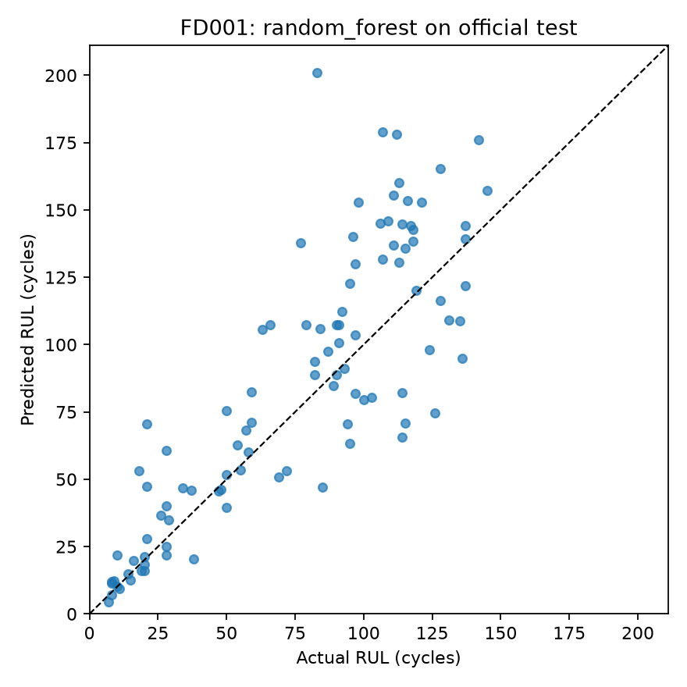  FD001 official test actual versus predicted RUL | 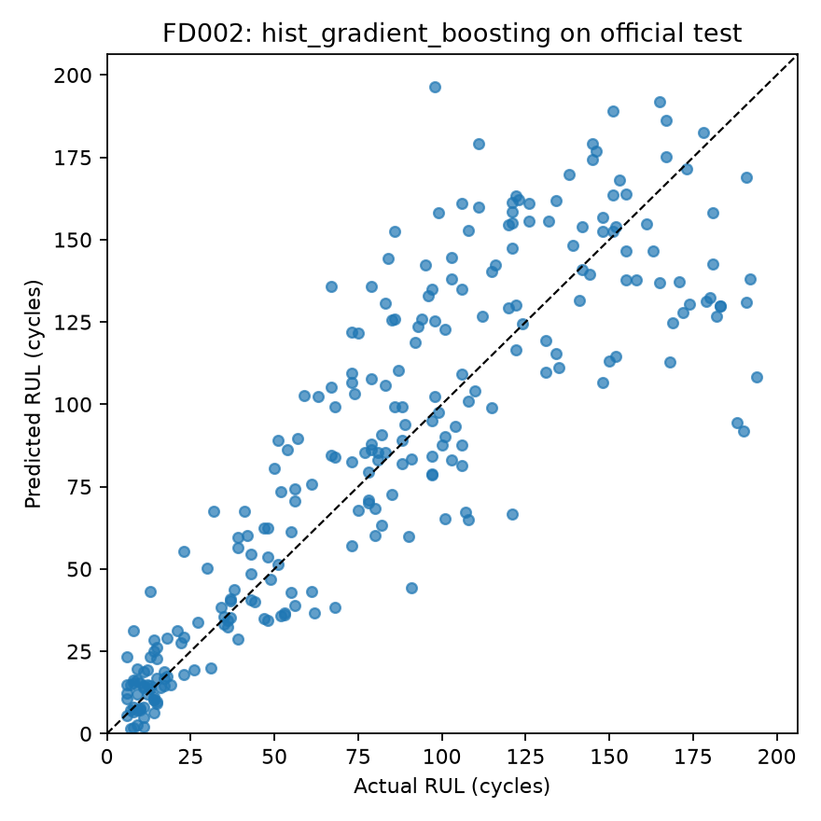  FD002 official test actual versus predicted RUL

Files to open during the review
Start in the project folder named Turbofan_RUL_CMAPSS_25_30_Percent 2. Open the following files in this order; do not spend the meeting walking through every generated file.
Show | File | What to point out
1 | docs/DATA_DICTIONARY.md | 26 raw fields: engine ID, cycle, 3 settings, 21 sensors.
2 | docs/MODELING_PROTOCOL.md | Engine-wise validation and test-label separation.
3 | reports/modeling/FD001/validation_metrics.csv | Four candidate models and FD001 winner.
4 | reports/modeling/FD001/official_test_metrics.csv | FD001 test score, not training score.
5 | reports/modeling/FD002/official_test_metrics.csv | FD002 test score.
6 | reports/modeling/FD001/official_test_actual_vs_predicted.png | FD001 prediction scatter.
7 | reports/modeling/FD002/official_test_actual_vs_predicted.png | FD002 prediction scatter.
8 | train_models.py | Show models and workflow briefly, if asked.

Suggested five person speaking split
This is a presentation plan, not a claim about who wrote each part. Replace member numbers with your actual speaking order.
- Member 1: 30-second recap of the RUL problem and the raw data; show the data dictionary.
- Member 2: preprocessing and model inputs; explain why sensor history uses no future cycles.
- Member 3: train, validation, and test design; explain the engine-wise split and model-selection rule.
- Member 4: FD001 validation comparison; explain why Random Forest was selected and why negative validation R² matters.
- Member 5: FD001 and FD002 test table and graphs; close with what will be covered in the final review.

Final review focus
Reserve the complete FD001–FD004 comparison, the error-by-RUL and overestimation analysis, limitations, and the final interpretation for the final presentation. The four-subset runs and error tables are already generated; the remaining presentation work is to consolidate and explain them, check the pending local file changes, and rehearse a clean end-to-end demonstration. Do not describe these completed runs as future experiments.

